EXPERIMENT NO:6
AIM: Configure a network and Implement RIP Routing.
TOOLS/SOFTWARES REQUIRED: Cisco Packet tracer
THEORY:
Routing is the process of forwarding data packets from one network to another through routers. When multiple networks are connected, routers need a method to exchange information about available routes. This is done using routing protocols. RIP (Routing Information Protocol) is one of the oldest and simplest dynamic routing protocols used for this purpose.
RIP is a distance-vector routing protocol that uses hop count as its metric to determine the best path to a destination network. The route with the smallest hop count is selected as the best route. The maximum hop count allowed in RIP is 15, and if the hop count becomes 16, the network is considered unreachable. RIP sends routing updates to its neighboring routers every 30 seconds to maintain updated routing tables. It works based on the Bellman-Ford algorithm.

OUTPUT
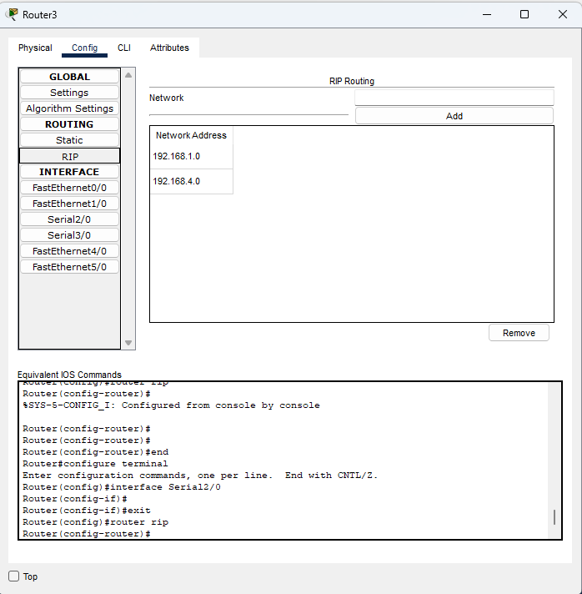
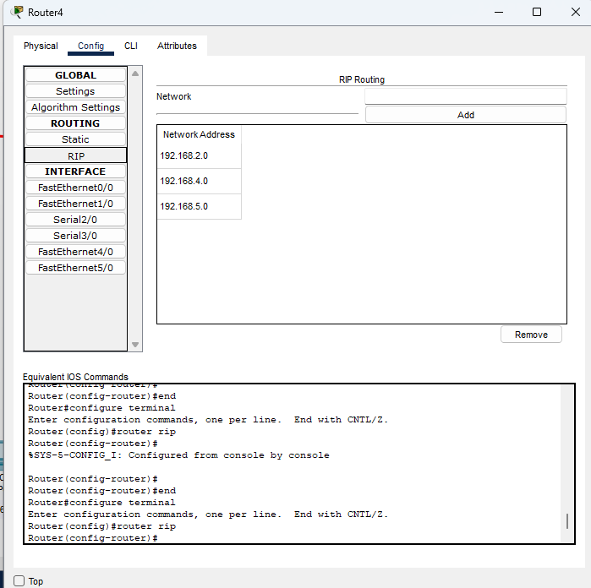
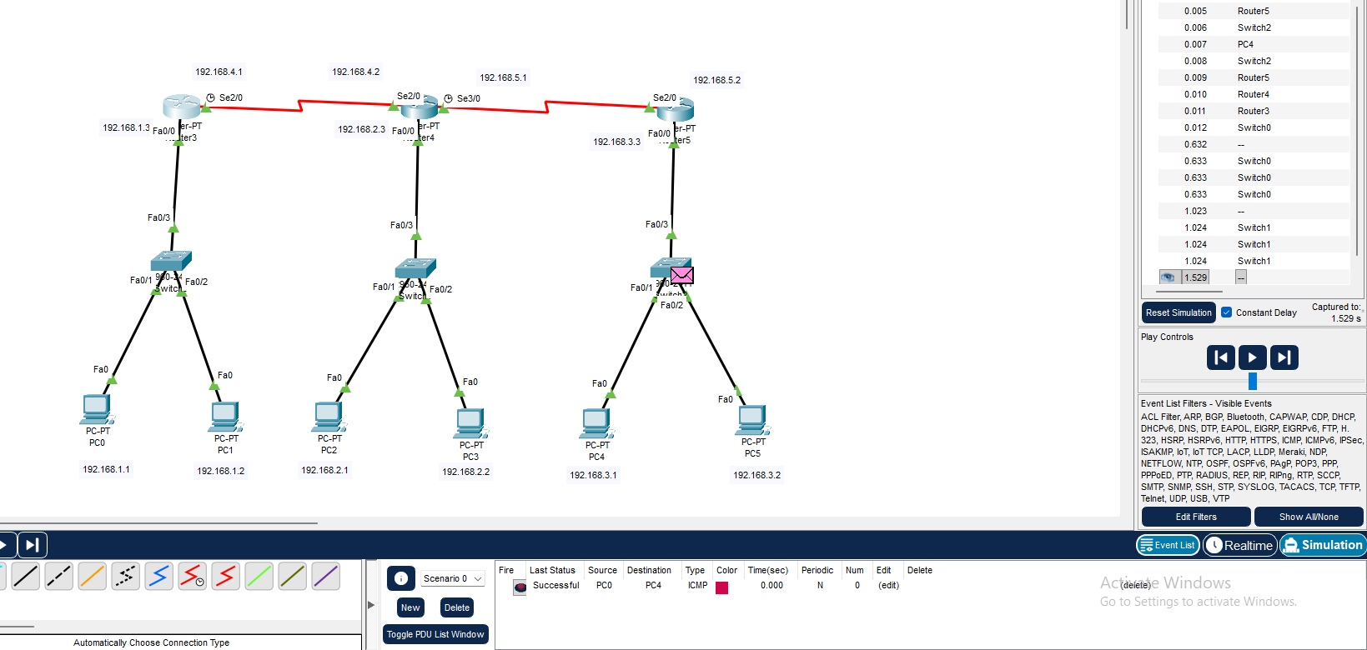
CONCLUSION:
In this experiment, routers are configured with IP addresses and connected through serial or Ethernet links. RIP is then enabled using router configuration mode so that routers can share routing information automatically. RIP is suitable for small networks because of its simple configuration and low resource requirements. However, it is not preferred for large networks due to its limited hop count and slower convergence time.

